***Jaccard Coefficient Calculations***

The table shows the pathological test results for three individuals:

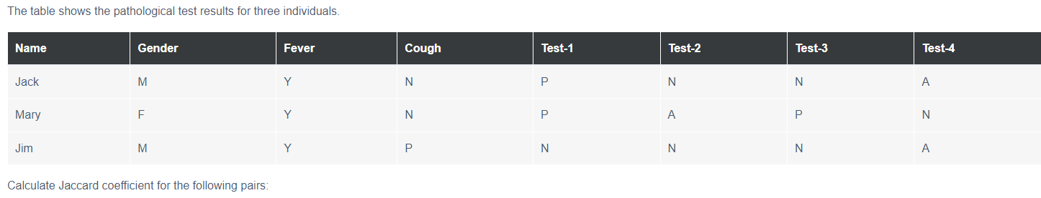

**Converting the table with exception of gender since has symmetric binary attribute**

|  |  |  |  |  |  |  |  |
| --- | --- | --- | --- | --- | --- | --- | --- |
|  | **Gender** | **Fever** | **Cough** | **Test-1** | **Test-2** | **Test-3** | **Test-4** |
| **Jack** | **M** | **1** | **0** | **1** | **0** | **0** | **0** |
| **Mary** | **F** | **1** | **0** | **1** | **0** | **1** | **0** |
| **Jim** | **M** | **1** | **1** | **0** | **0** | **0** | **0** |

Jaccard = (f01+f10) / (f01+f10+f11)

1. **(Jack, Mary)**

(f01 + f10) = 1 + 0 = 1

(f01+f10+f11) = 1 + 0 + 2 = 3

Jaccard coefficient = 1/3 = 0.33

1. **(Jack, Jim)**

(f01 + f10) = 1 + 1 = 2

(f01+f10+f11) = 1 + 1 + 1 = 3

Jaccard coefficient = 2/3 = 0.67

1. **(Jim, Mary)**

(f01 + f10) = 1 + 2 = 2

(f01+f10+f11) = 1 + 2 + 1 = 3

Jaccard coefficient = 2/3 = 0.75

**Observation:**

* Mary is more close to Jim than to Jack
* Jack is more close to Jim than to Mary